3B Physics: Particles, Waves and Quanta

Assignment Two
Name: _____________________________________________________ (60 marks)

- You know that electromagnetic radiation exhibits a “dual nature”. With examples, explain
what is meant by a “dual nature”? (2 marks)
_____________________________________________________________________________
_____________________________________________________________________________
_____________________________________________________________________________
_____________________________________________________________________________
_____________________________________________________________________________
_____________________________________________________________________________
_____________________________________________________________________________
_____________________________________________________________________________
_____________________________________________________________________________
- A neon sign emits photons of wavelength 7.10 x 10⁻⁷ m.
- To which region of the electromagnetic spectrum do these photons belong? (1 mark)
___________________________________________________________________________
- What is the energy of the photons in electron volts. (3 marks)

- An advertisement for a new laundry detergent boasts:
“DAZZLE laundry detergent makes your clothes WHITER than WHITE.”
Describe how laundry detergent manufacturers can cause clothes to appear to produce white light. (3 marks)
_____________________________________________________________________________
_____________________________________________________________________________
_____________________________________________________________________________
_____________________________________________________________________________
_____________________________________________________________________________
_____________________________________________________________________________
_____________________________________________________________________________
_____________________________________________________________________________

- Look at the two spectrums below. Name the type of spectrum produced in each case, A and B, then explain the formation of each including an example. (6 marks)
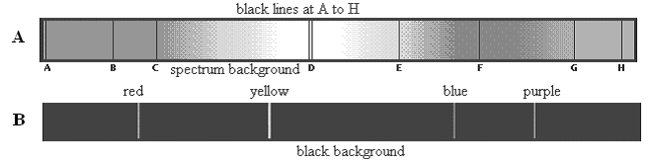

_____________________________________________________________________________
_____________________________________________________________________________
_____________________________________________________________________________
_____________________________________________________________________________
_____________________________________________________________________________
_____________________________________________________________________________
_____________________________________________________________________________
_____________________________________________________________________________
_____________________________________________________________________________
_____________________________________________________________________________
_____________________________________________________________________________
_____________________________________________________________________________
- Explain the difference between a photon and a quantum. (2 marks)
_____________________________________________________________________________
____________________________________________________________________________
_____________________________________________________________________________
_____________________________________________________________________________
- When looking at the sun through a spectroscope, a spectrum can be seen which has thin black lines on it.
  - What is the name given to this type of spectrum? __________________________(1 mark)
  - What is the name given to these black lines (in your text so look it up)?
__________________________________________________________________(1 mark)
  - Why do they occur? ________________________________________________________
_________________________________________________________________________
_________________________________________________________________________
_________________________________________________________________________
_________________________________________________________________________
_________________________________________________________________________
_________________________________________________________________________
_________________________________________________________________(2 marks)
- a. Look at the energy level diagram for an atom. How many possible transitions are there for this
atom (write the number in the space provided below), draw them. (2 marks)

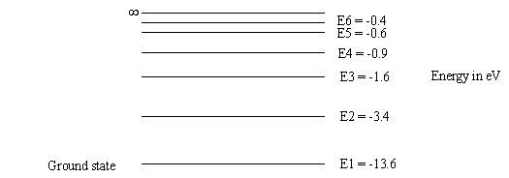

Number of transitions = ________________________ (2 marks)

- In the energy transition diagram above, what would happen if an electron were given 14.8 eV?
What name do we give to this? (2 marks)

__________________________________________________________________________
__________________________________________________________________________
__________________________________________________________________________
__________________________________________________________________________
- An electron in the diagram above is given enough energy to jump to the third level. It then returns to ground state via the second level where it emits light. What colour is the light?
(4 marks)

- A microwave has a frequency of 3.40 x 10¹⁰ Hz. If the microwave has a power output of 900 W, how many photons per second are transmitted? (2 marks)

- Strong nuclear forces hold protons and neutrons together. Protons and neutrons are hadrons and each hadron is made up of three quarks. There are six types of quarks each of which has a fractional charge. Up-type quarks have a charge of +2/3 electric charge, while down-type quarks have -1/3 electric charge. If an electric charge is the charge on an electron, determine the quarks that make up a neutron and a proton. You must show your working to justify your answer.

- a neutron (2 marks)

- a proton (2 marks)

- While astronomers still use light telescopes to view the universe, much more information is available by using other waves within the electromagnetic spectrum such as radio-waves, infra-red waves, ultra-violet waves and X-rays. Select ONE of these and explain what information is available that is not visible using a light telescope. (3 marks)

____________________________________________________________________________________________________________________________________________________________________________________________________________________________________________________________________________________________________________________________________________________________________________________________________________________________________________________________________________________________________________________________________________________________________________________________________________________________________________________________________________________________________________________________________________________________________________________________________________
- Label the following diagram showing the production of X-rays. (3 marks)
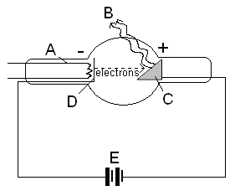

A: _______________________________________

B: _______________________________________

C: _______________________________________

D: _______________________________________

E: _______________________________________

- Describe and explain the following fundamental cosmological concepts.
- How red-shift is evidence of the Big Bang Theory. (3 marks)
____________________________________________________________________________________________________________________________________________________________________________________________________________________________________________________________________________________________________________________________________________________________________________________________________________________________________________________________________________________________________________________________________________________________________________________________________________________________________________________________________________________________________________________________________________________________________________________________________________________________________________________________________________________________________________________________________________________________________________________________________________________________________________________________________________
- The two proposed models for the behaviour of the universe. (2 marks)
__________________________________________________________________________________________________________________________________________________________________________________________________________________________________________________________________________________________________________________________________________________________________________________________________________________________________________________________________________________________________________________________________________________________________________________________________________________________________________________________________________________________________________________________________________________________________________________________________________________________________________________________________________________________________________________________________________________________________________________________________
- Hubble’s law, red-shift and the expanding universe. (2 marks)
________________________________________________________________________________________________________________________________________________________________________________________________________________________________________________________________________________________________________________________________________________________________________________________________________________________________________________________________________________________________________________________________________________________________________________________________________________________
- A spaceship of the future is travelling at 90% the speed of light. It is travelling to Alpha Centauri B, which is believed to have a sister planet to Earth, to see if life is exists on this planet.
- If Alpha Centauri B is 4.32 light years from Earth, how long will it take for the spaceship to get to the planet? (2 marks)

- When travelling close to the speed of light, time dilation occurs and the time for the passengers on the spaceship appears shorter. The apparent time, t₀, can be found using the time dilation equation and the actual time, t.

$t_{0}=tx\sqrt{1−\frac{v^{2}}{c^{2}}}$
Calculate the apparent time according to the passengers. (2 marks)

- The spaceship can’t go any faster as due to Einstein’s equation, E = mc², when travelling close to the speed of light, some of the energy used to accelerate the spaceship is converted to mass. Using Einstein’s mathematical equation,
$m_{v}=\frac{m_{0}}{\sqrt{1−\frac{v^{2}}{c^{2}}}}$ where m_{v} = the mass when moving and m₀ = the resting mass.
If the spaceship has a mass of 3.70 x 10⁶ kg when orbiting Earth, what will be its mass when travelling at 90% the speed of light? (2 marks)

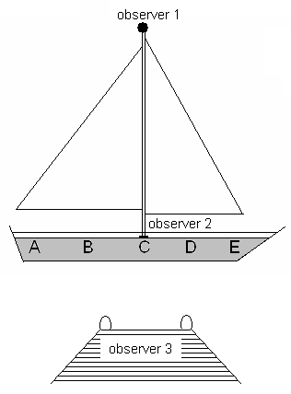
- Galileo described a thought experiment in which a sailor, observer 1, drops an object from the tall mast of a sailing ship which is moving at a steady velocity eastwards. Observer 2 is standing just to the right of point C. Observer 3 is on a jetty watching the sailing ship pass by.

At what position would you predict the object will land for

- observer 1: ________
- observer 2: ________
- observer 3: ________ (2 marks)

- A passenger on a train is walking at 2.50 m s⁻¹ towards the rear of the train. The train is travelling forward at 15.0 m s⁻¹. Relative to an observer on the ground nearby, what is the speed of the passenger? (2 marks)

